Identification of Components of Orient 21J 46931 Movement

1. Automatic winding module

Include: Rotor, Rotor plate, bearing

Function: The unbalanced rotor rotates around the central point when swung, combined with other mechanisms in the automatic winding module, wind the spring.

Located: Top of the movement side.

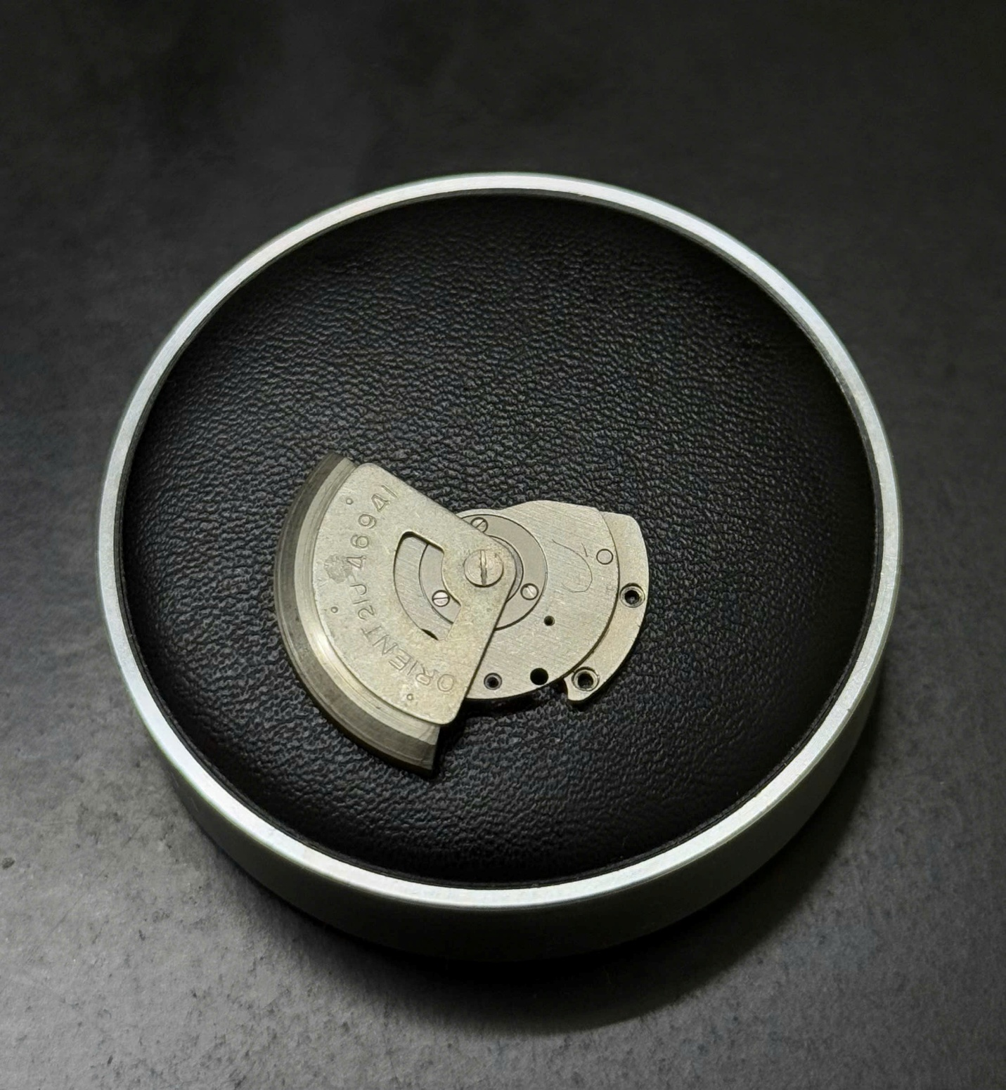

Picture 1: Rotor attached to rotor bridge

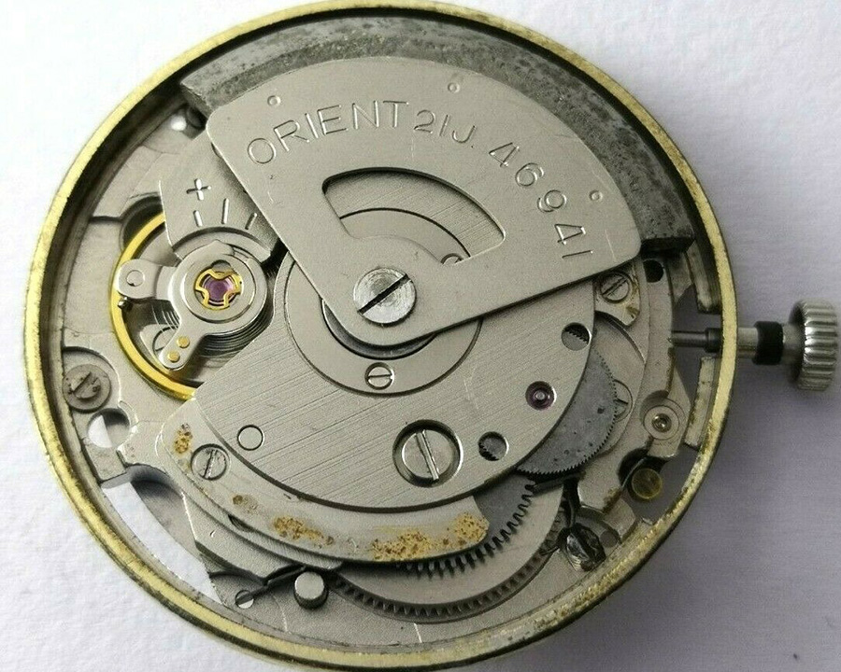

Picture 2: Movement before removal of part

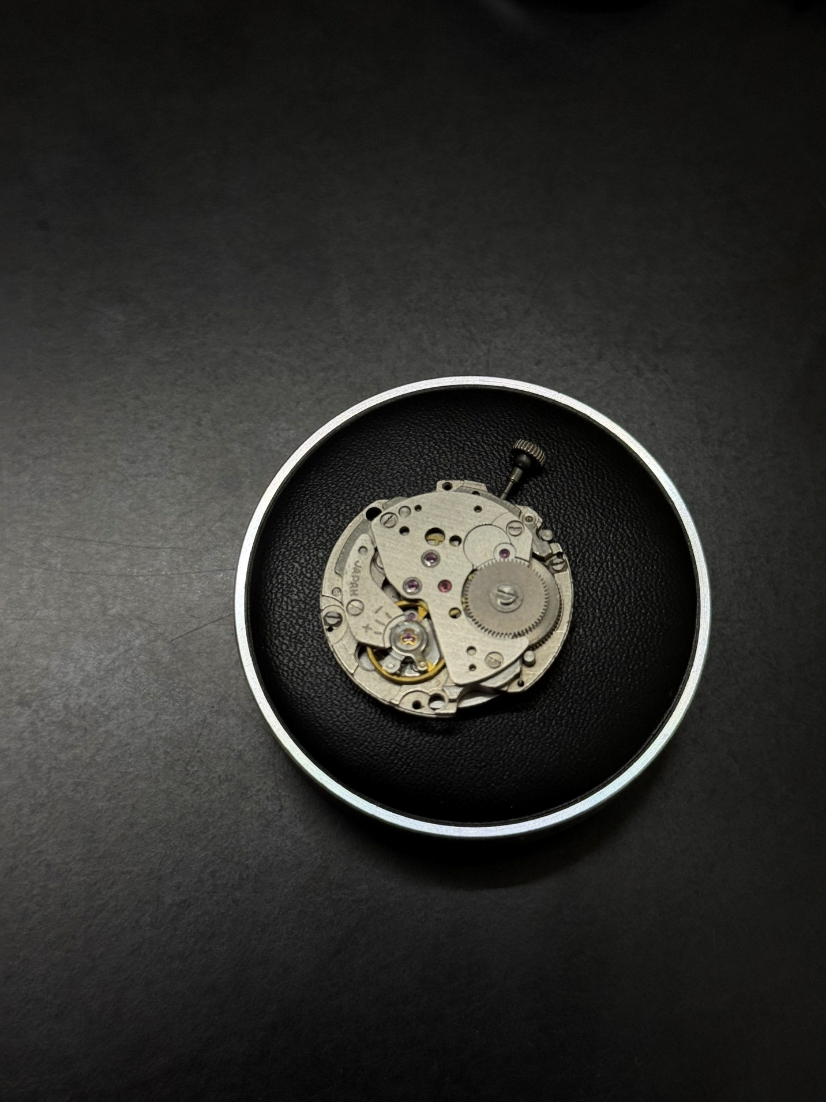

Picture 3: Movement after removal of part

1. Barrel

Function: Inside the barrel stores the main spring, which supplies and stores energy for the watch.

Include: Barrel and barrel bridge

Location: Right below the automatic winding module

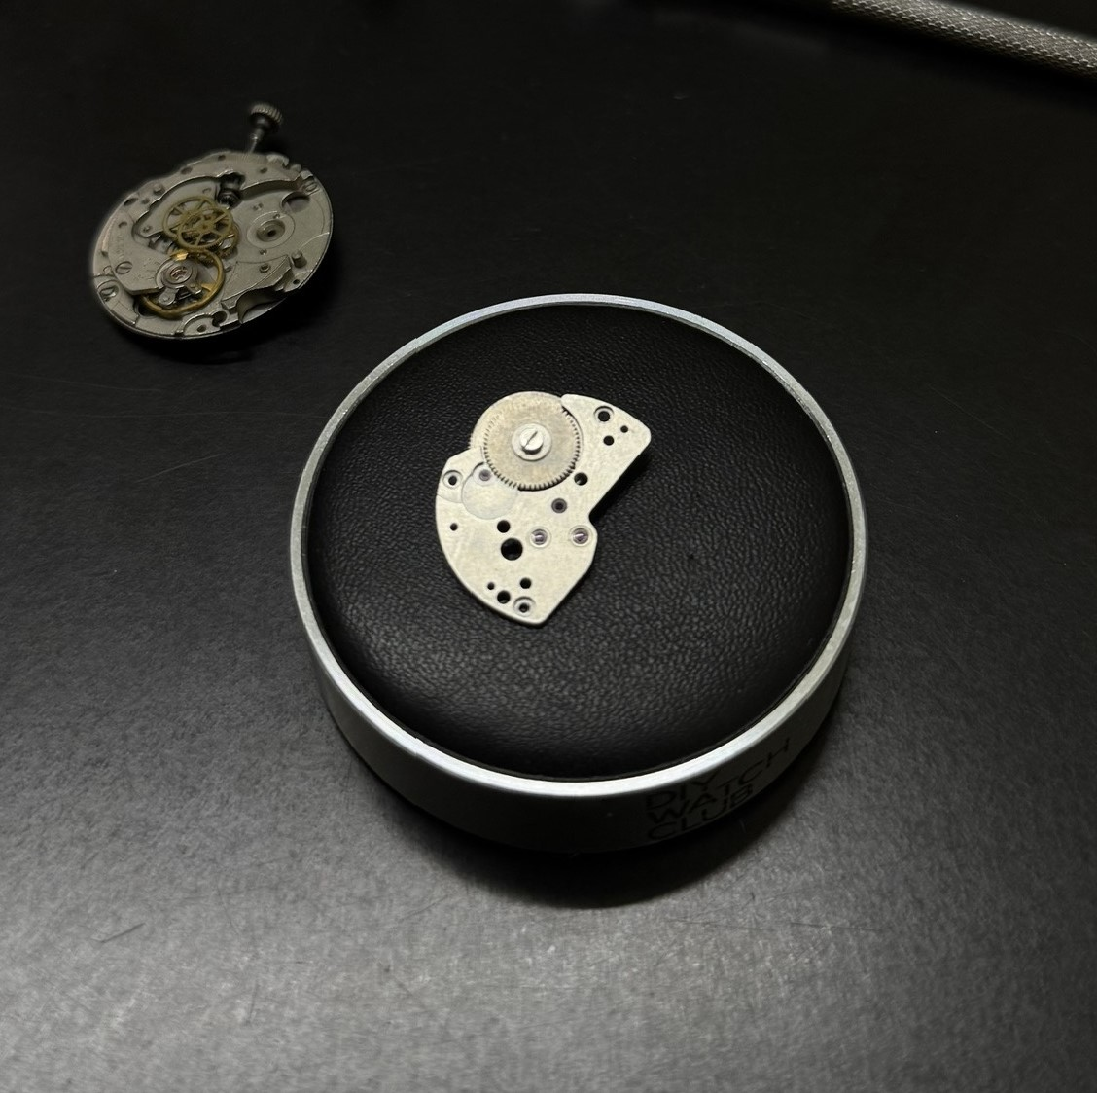

Pic 4: Barrel module

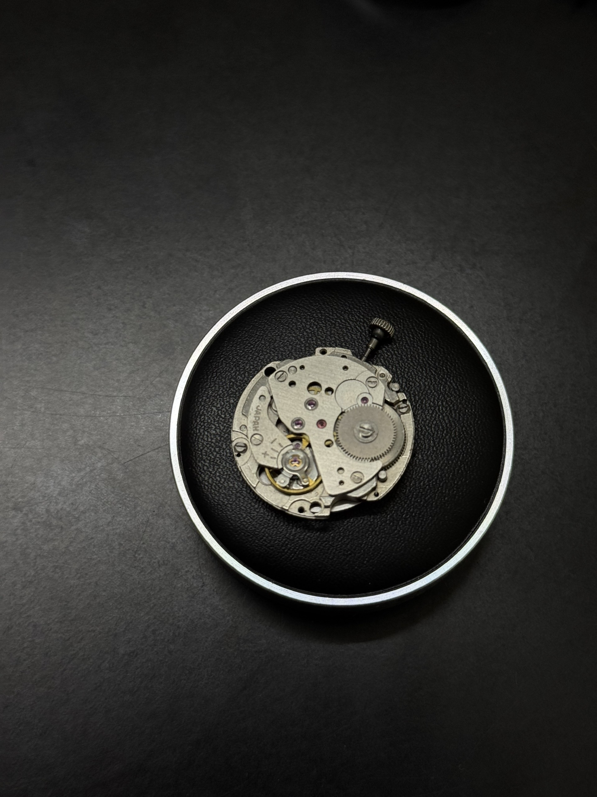

Pic 5: Movement after removal of part

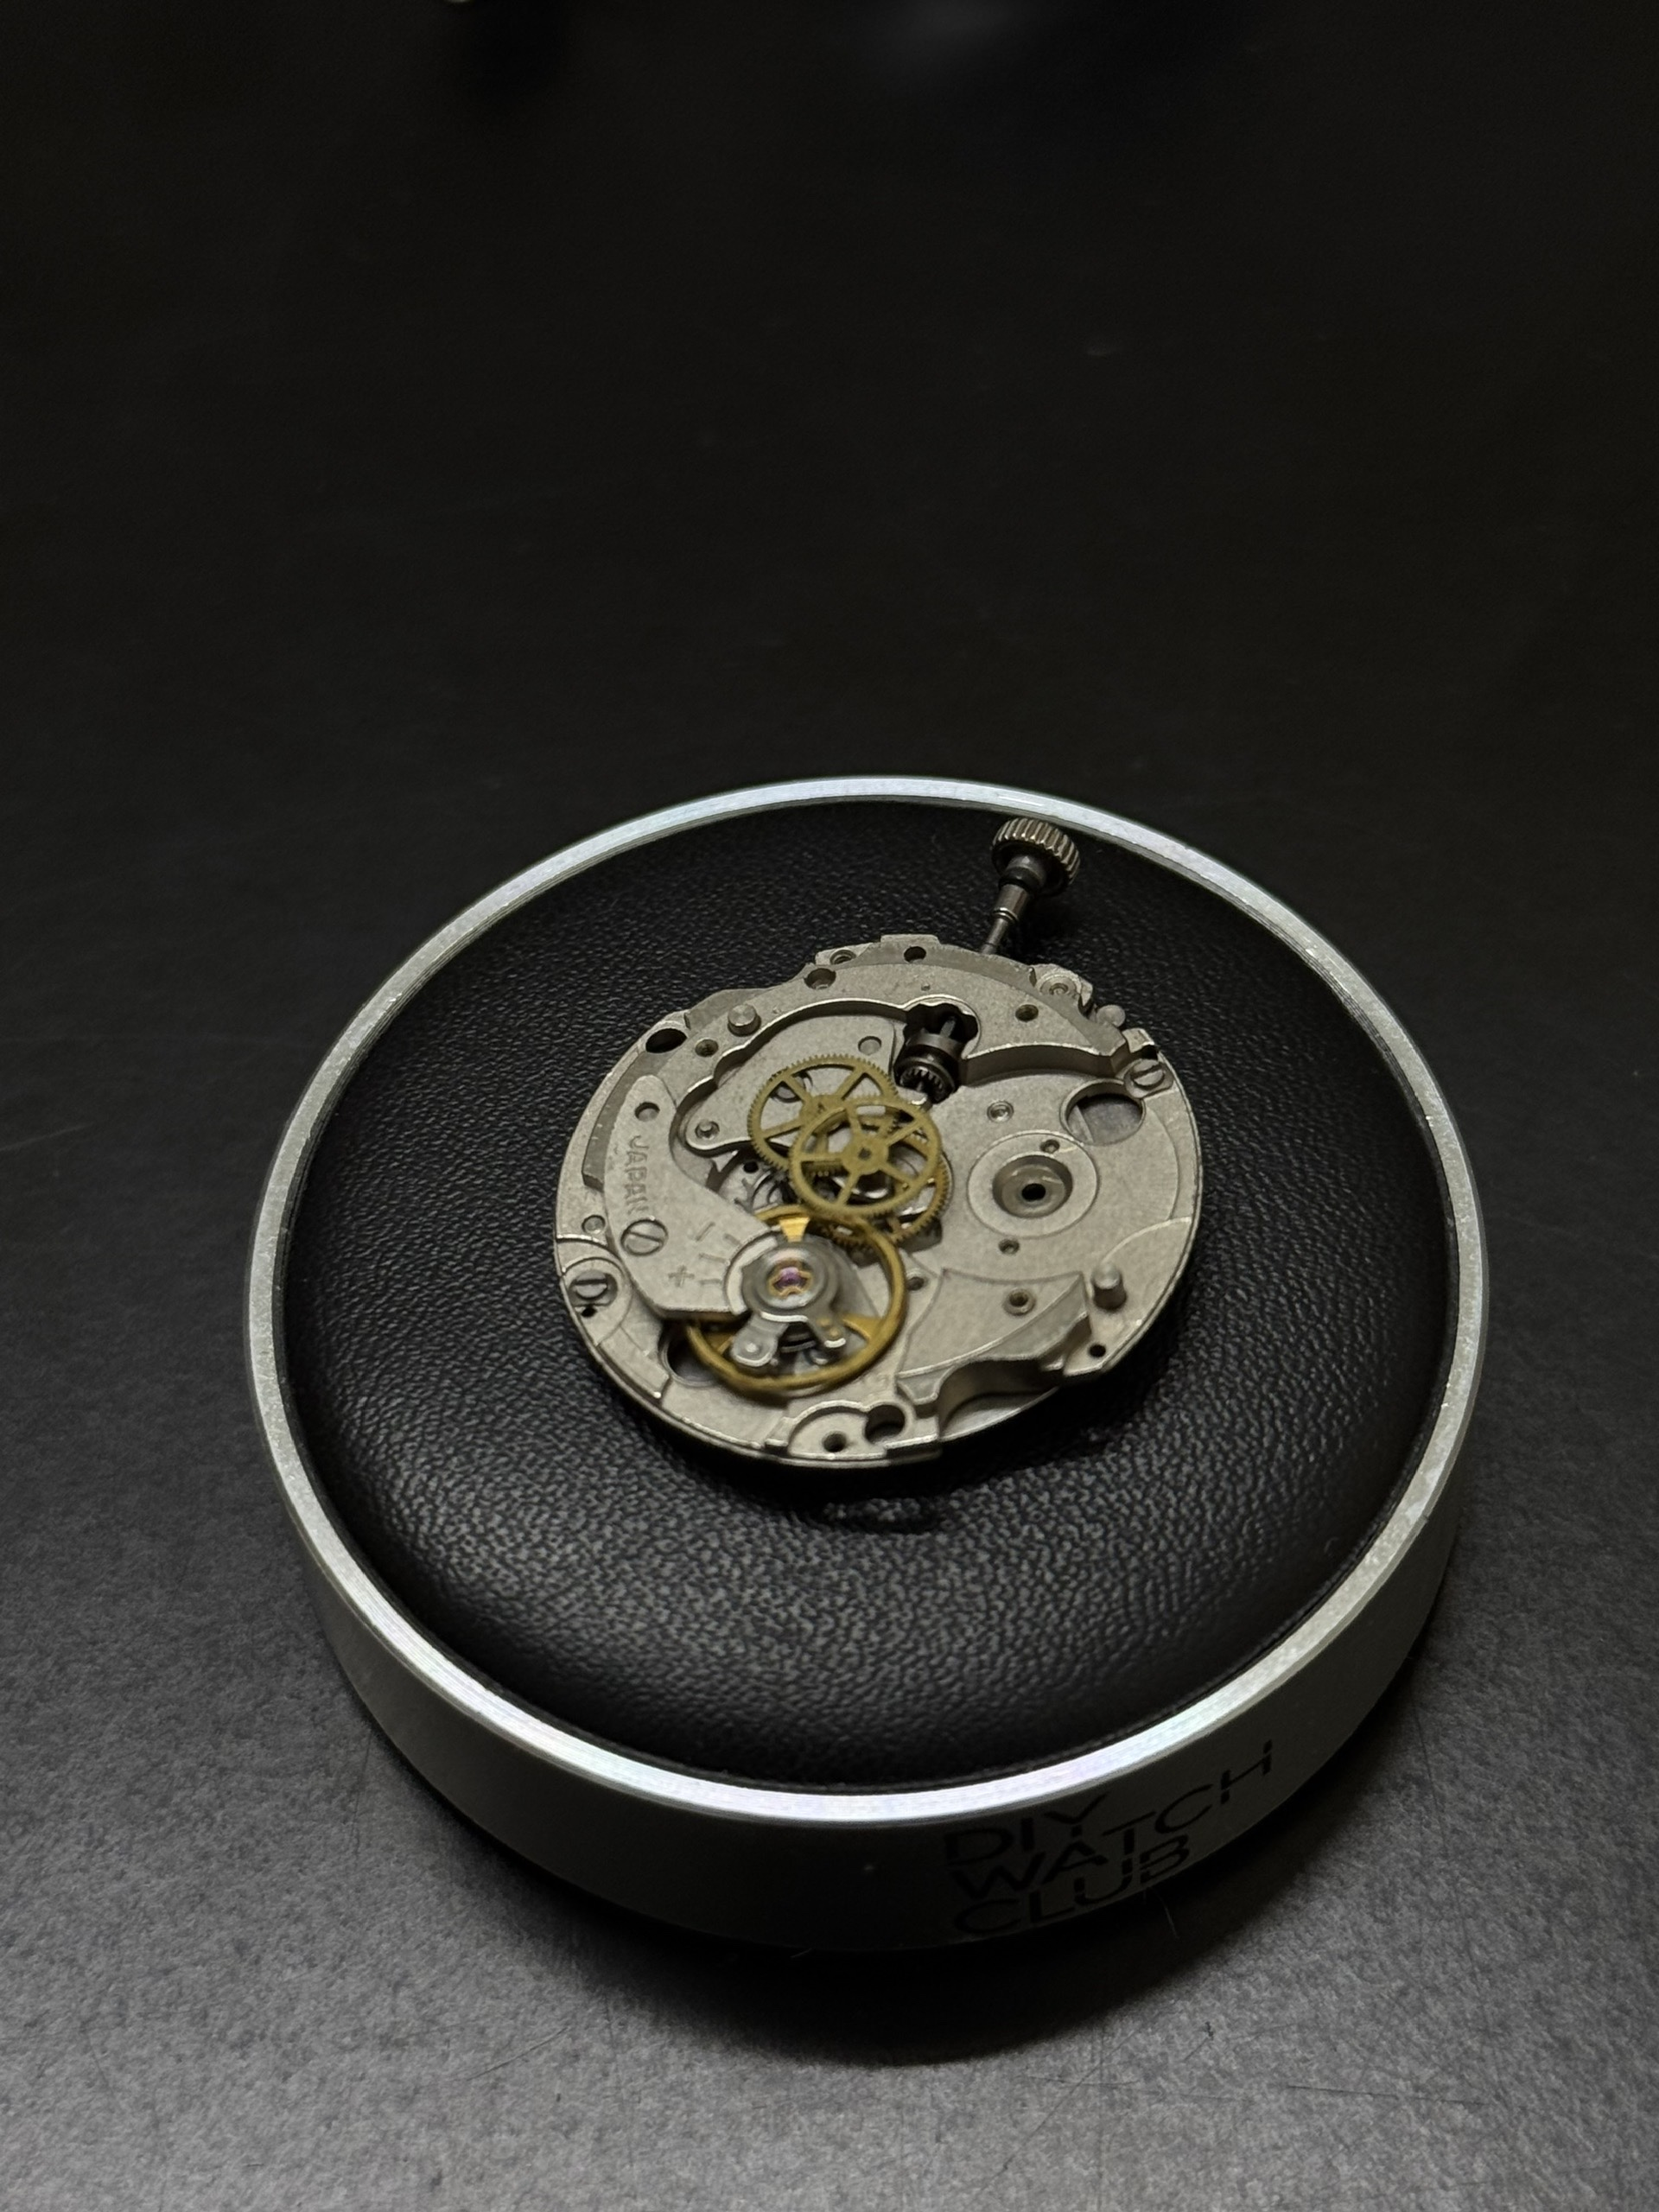

Pic 6: Movement before removal of part

1. Gear train

Function: Control and transmit energy from the barrel, eg: Allow the second hand to rotate 1 full circle in 1 minute, etc

Components: Main (center) gear, third gear, fourth gear.

Shared components: Barrel (also a gear), escape gear (commonly referred to in the escapement module)



Pic 7: Fully assembled gear train

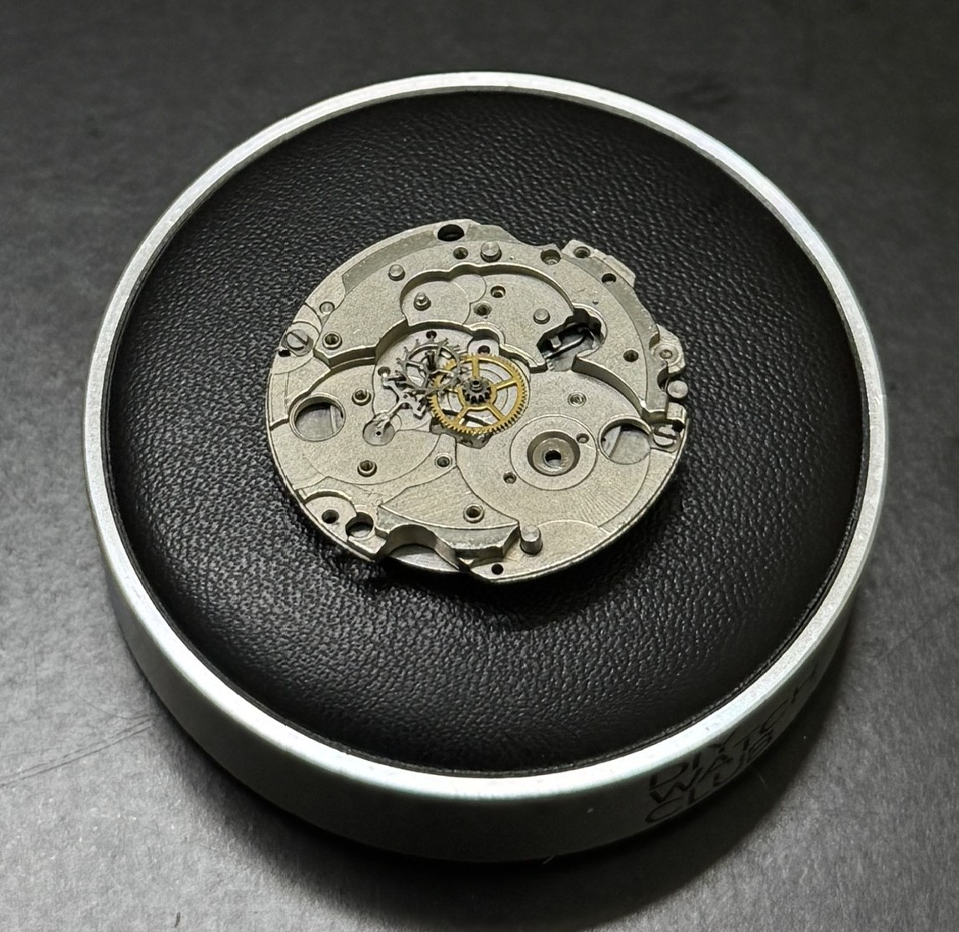

Pic 8: Center gear with pallet fork and escape gear assembly

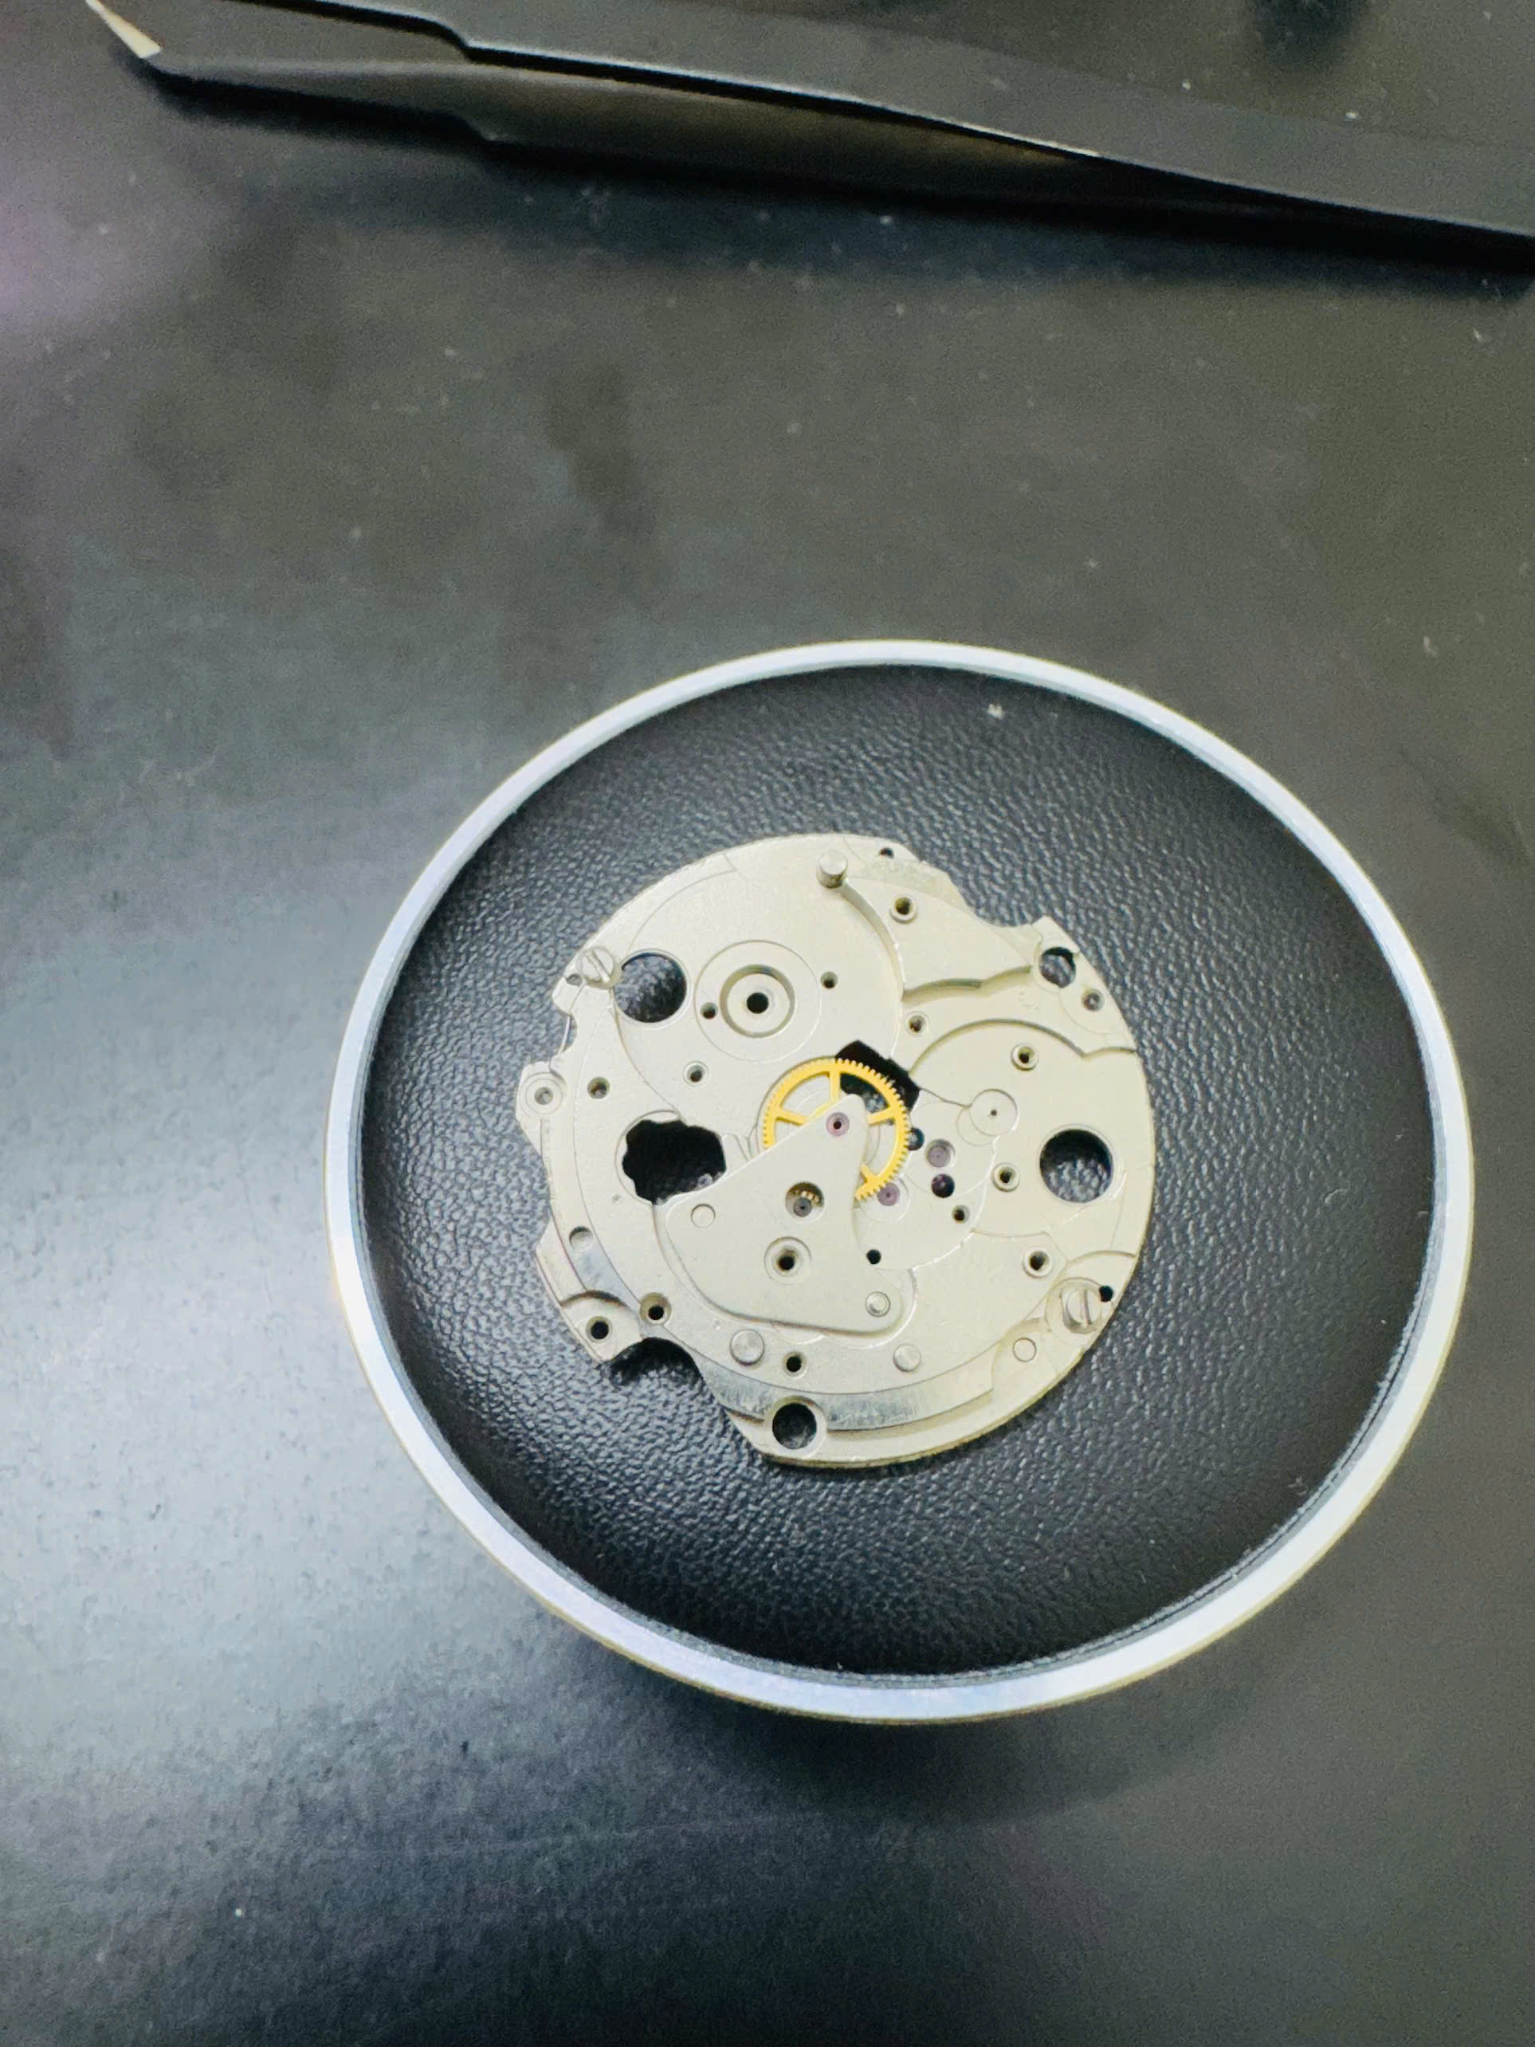

Pic 9: Center gear below the center gear bridge

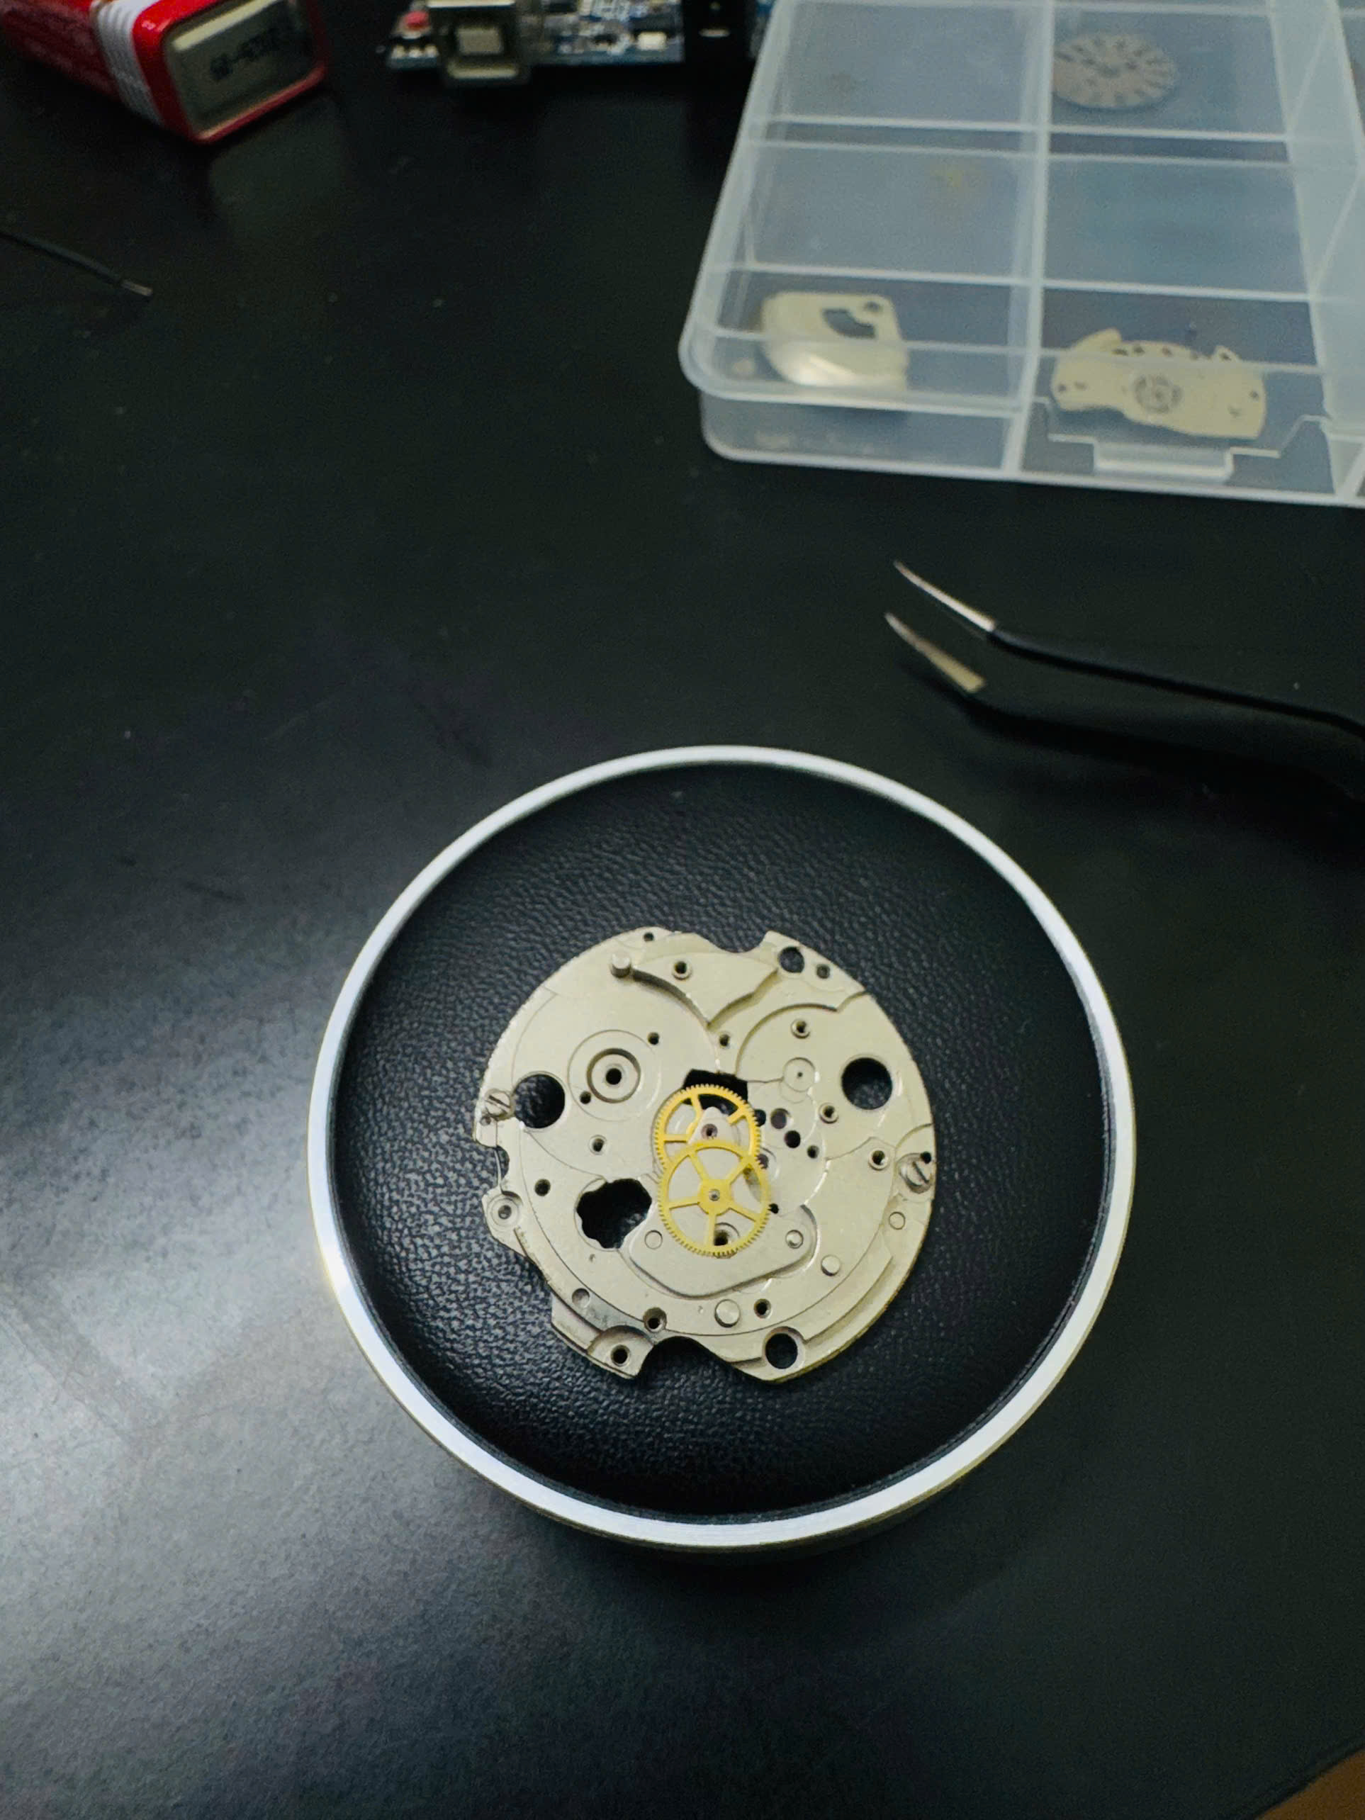

Pic 10: Third gear added to the above assembly

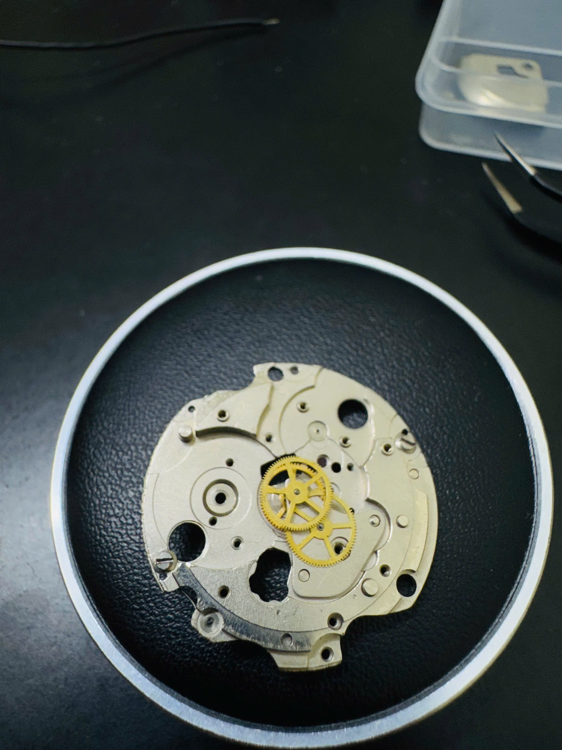

Pic 11: Fourth gear added

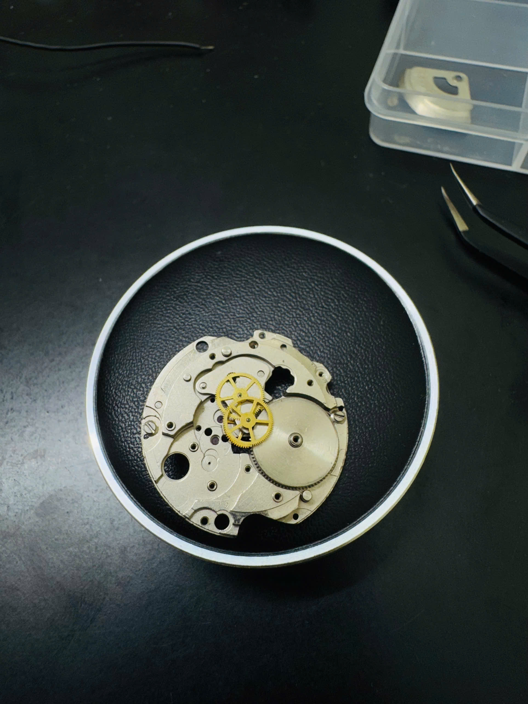

Pic 12: Barrel (gear) added. Turning the barrel gear leads to all gear turning.

1. Escapement

Function: Control the energy released by the barrel, and turn that energy into meaningful beat.

Components: Balance wheel, pallet fork, escape gear

Location: Movement side, opposite side of the crown

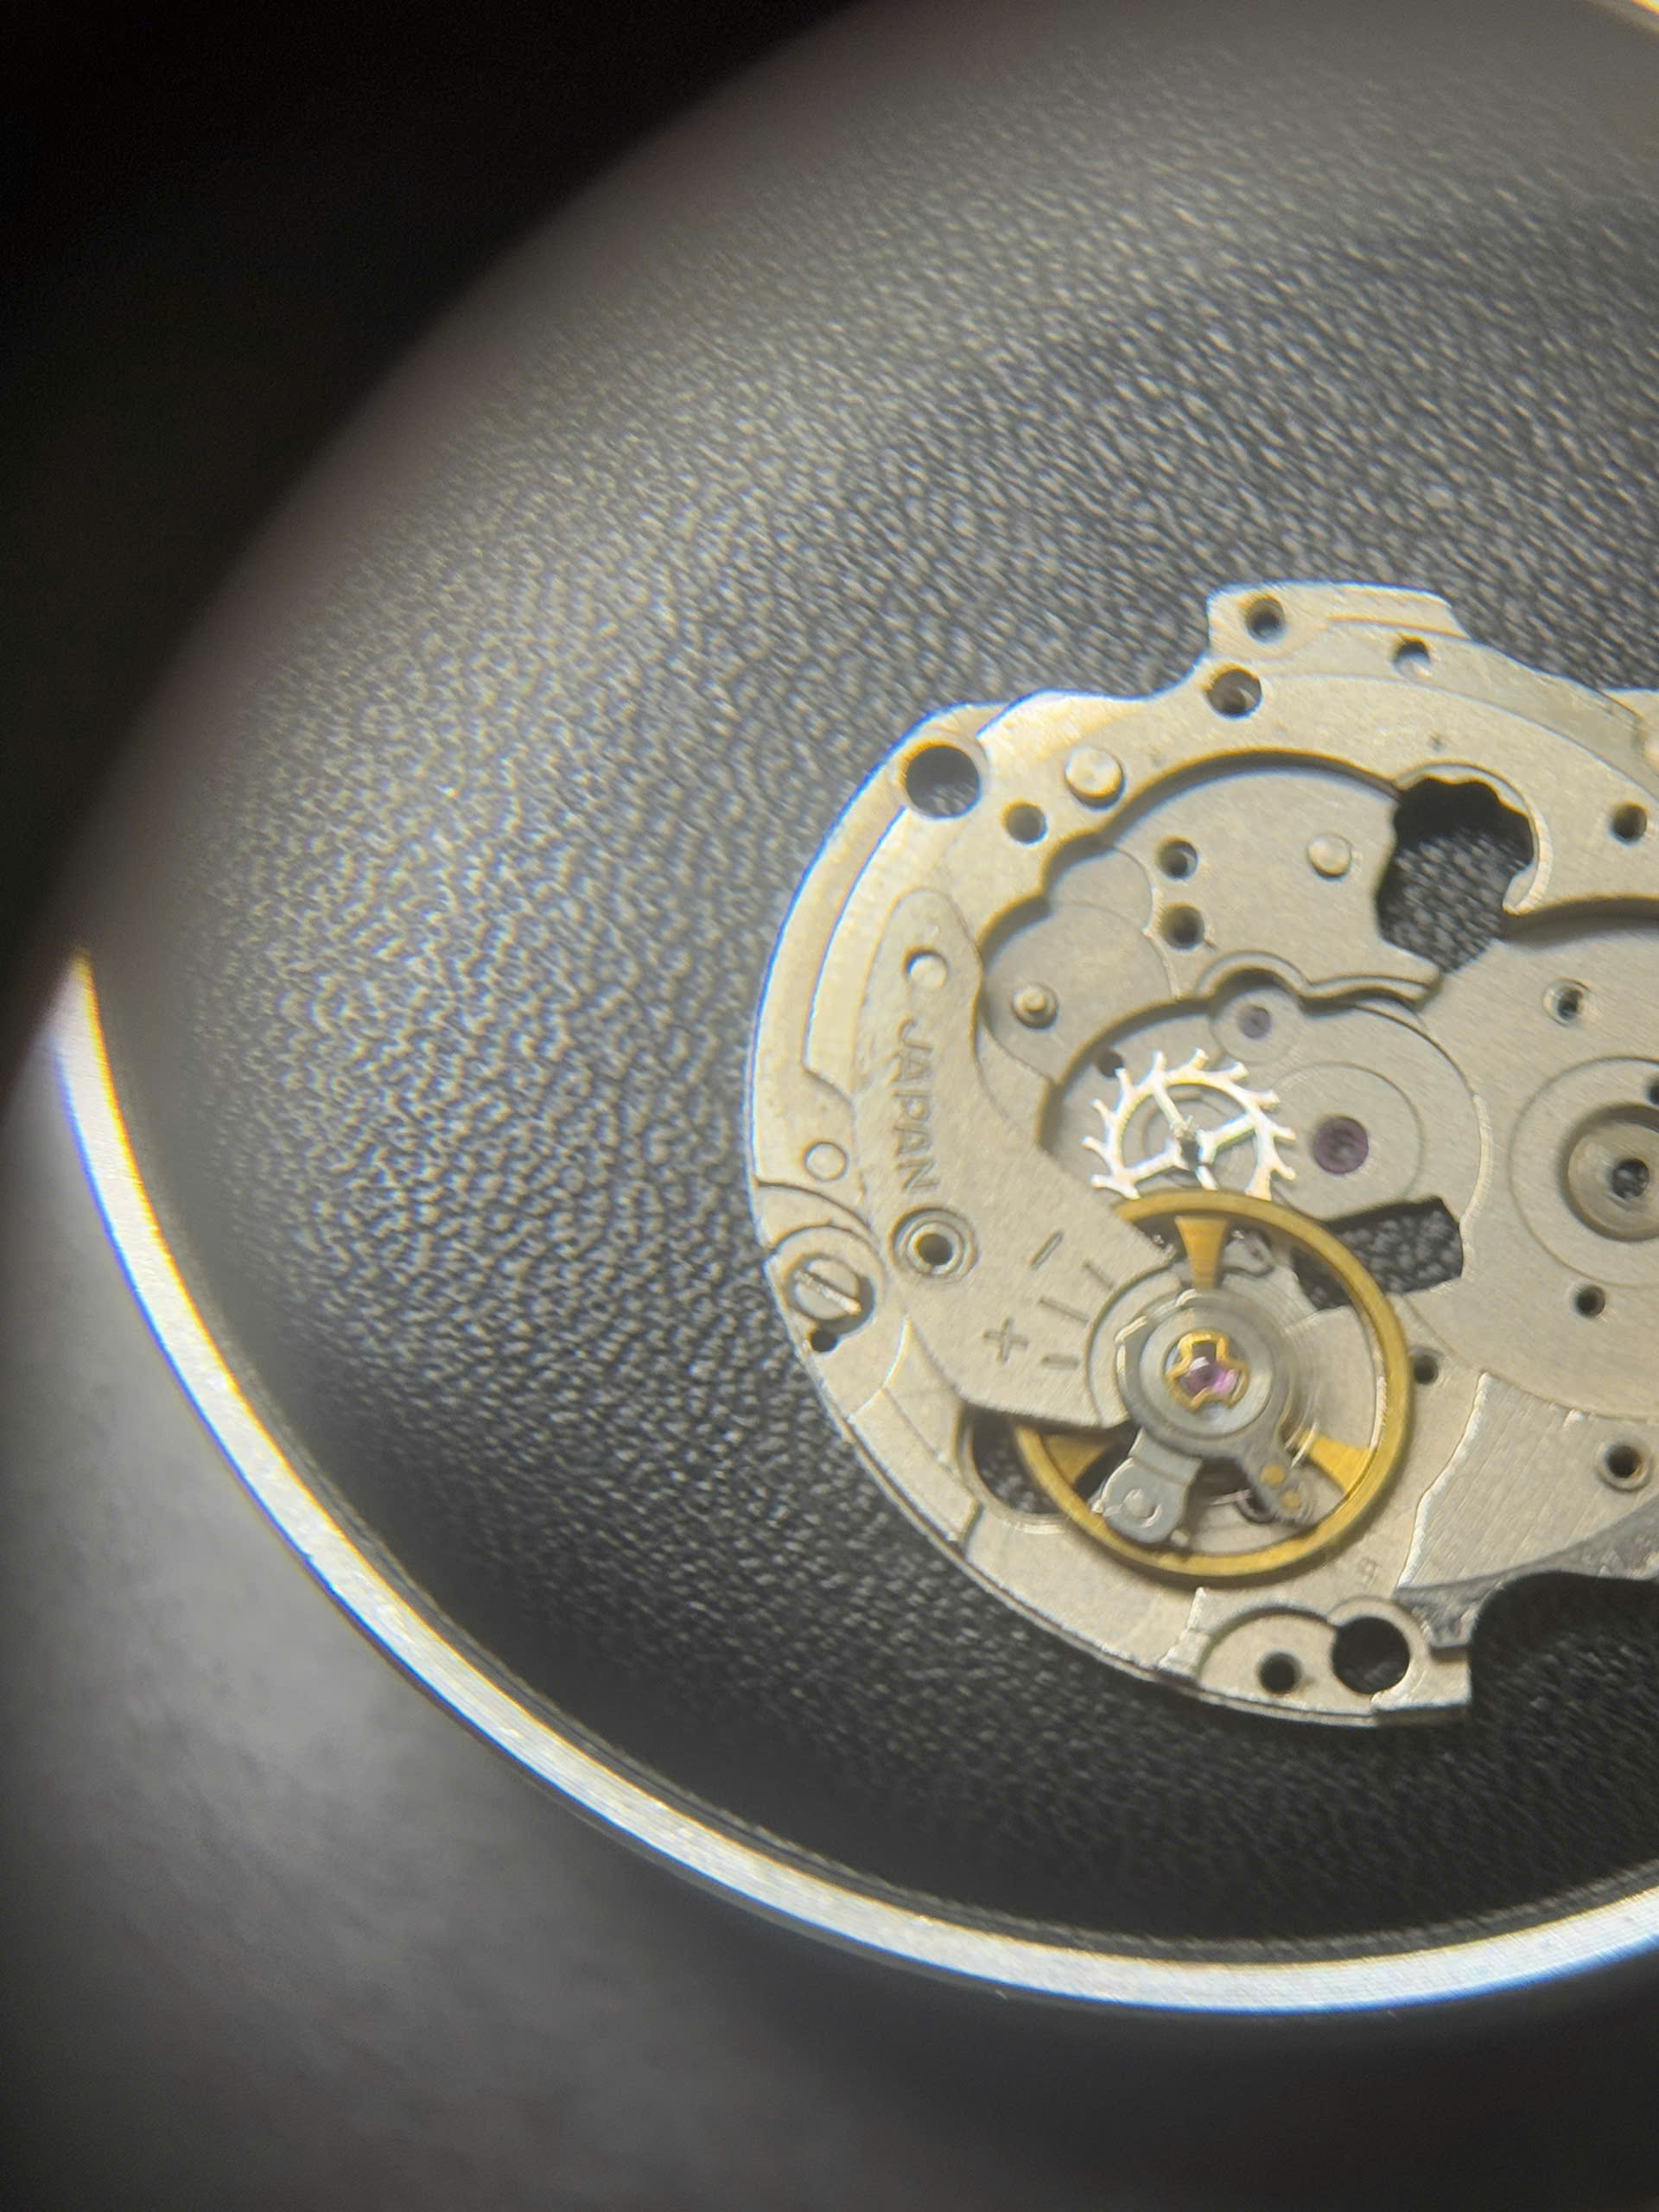

Picture: Escapement full assembly

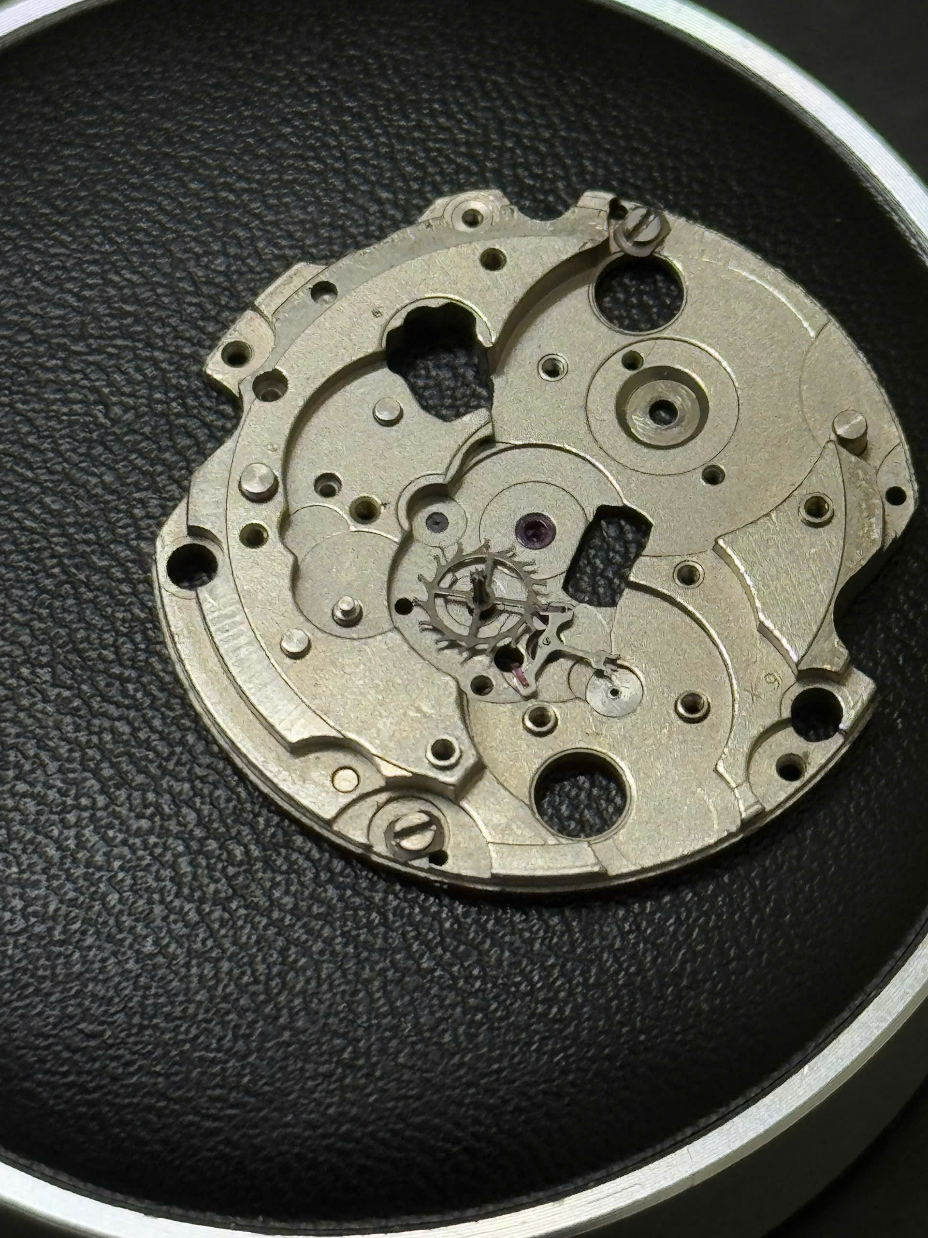

Picture: Pallet fork and escape wheel assembly



Picture: Original escapement assembly. Only the balance wheel is visible

1. Winding mechanism

Function: Setting the time, day and date. Winding the barrel

Components: Stem and clutch. Setting lever and setting lever spring. Setting lever cover plate

Location: Sandwiched in the middle of the movement, on the dial size of the main plate.

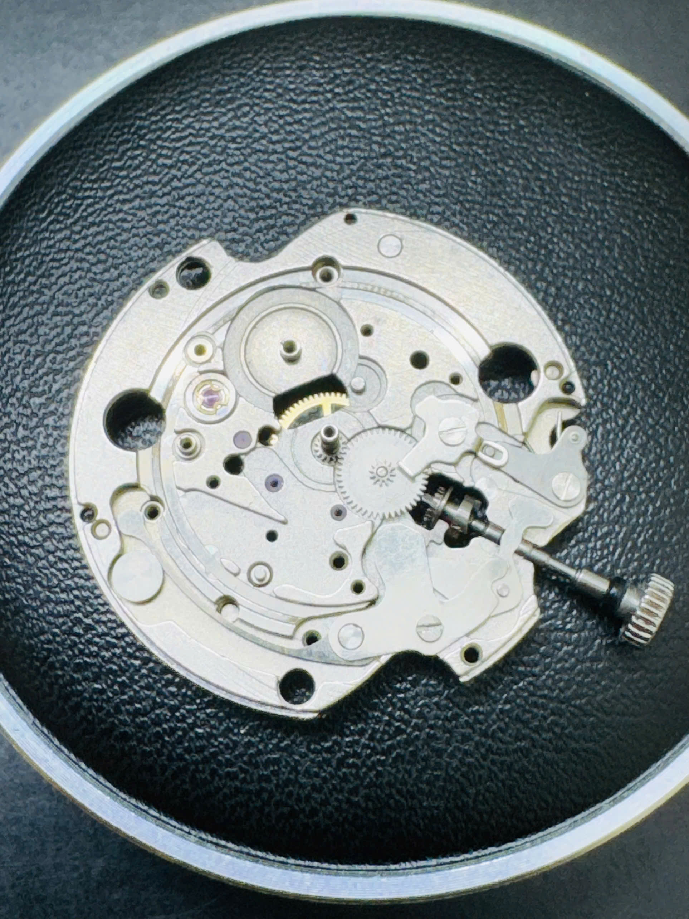

Picture xxx: Setting mechanism in normal position

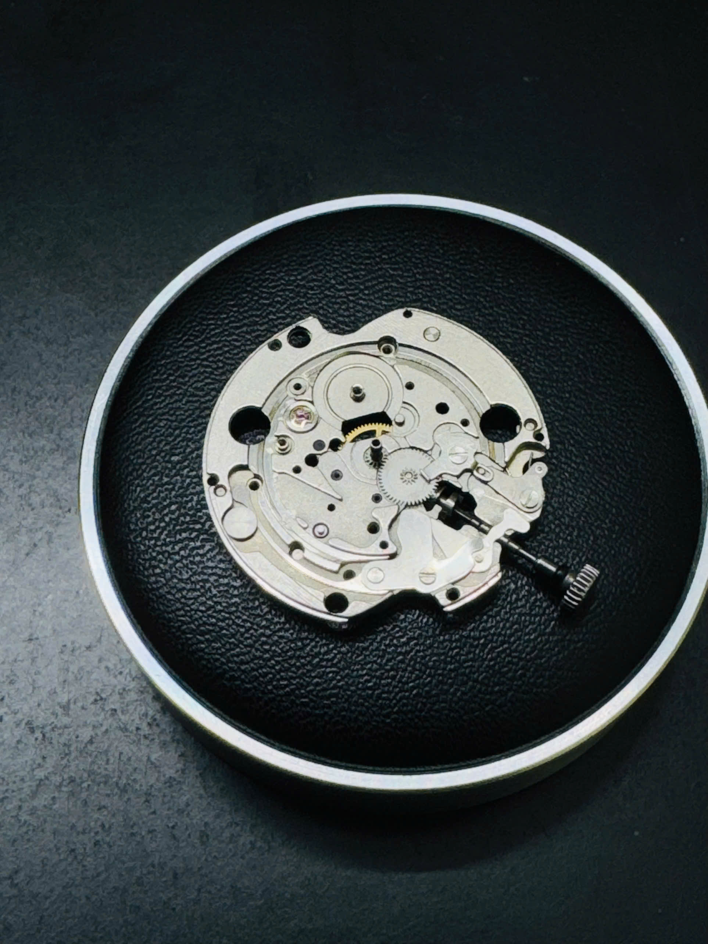

Picture yyy: Setting mechanism in setting position

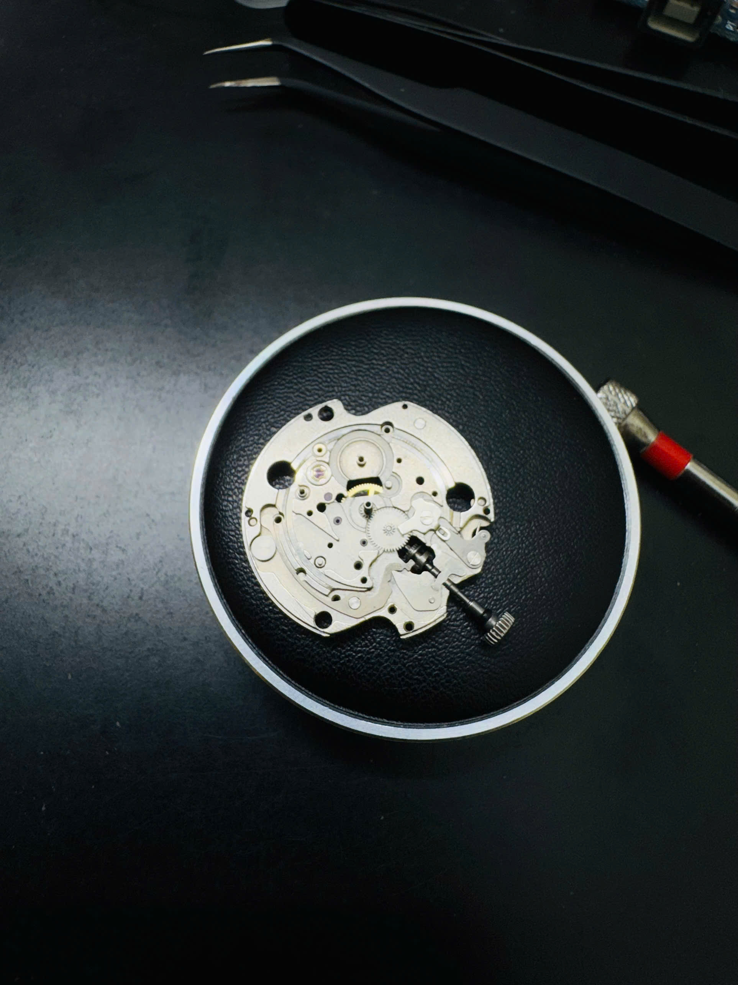

Picture zzz: Setting mechanism without cover plate

1. Day disc

Function: Telling the day of the month

Components: Day wheel, Day corrector wheel, Day jumper spring, Day disc

Location: Top of the dial size

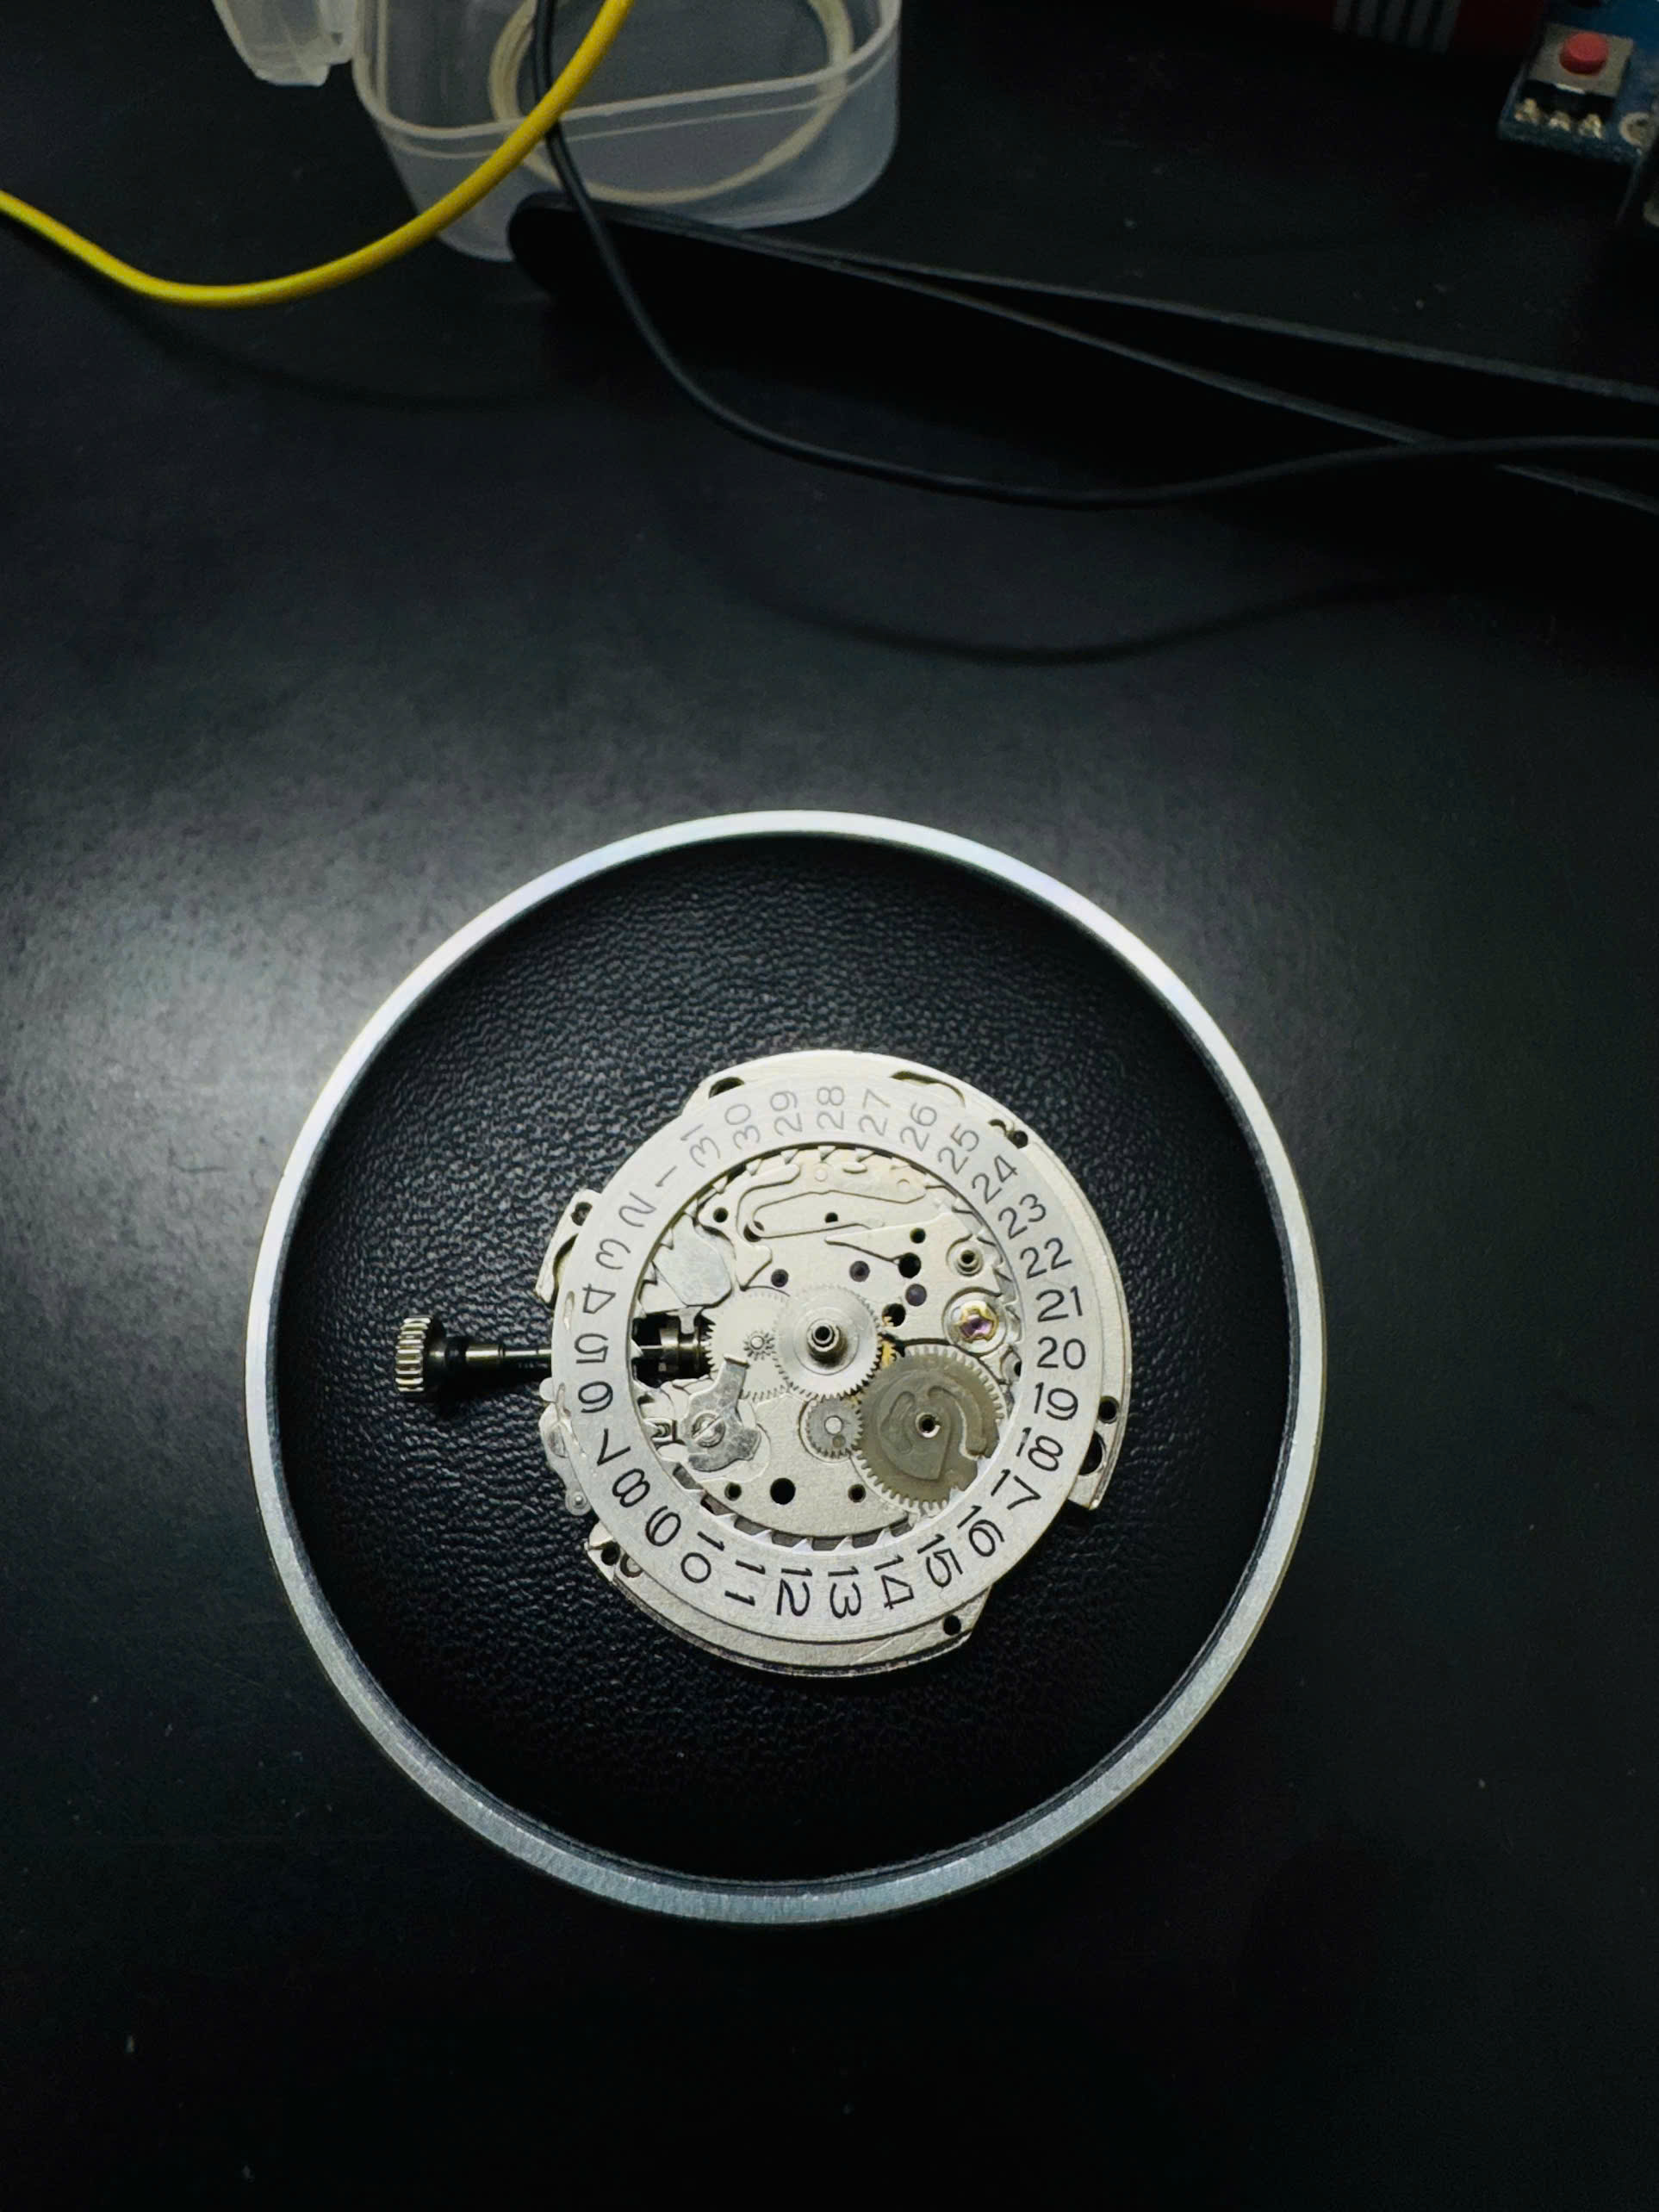

Pic: Full assembly of the day disc



Pic: Before assembling the day disc module

1. Day of the week module

Function: Show the day of the week

Components: Day-of-the-week disc, jumper spring, day star

Location: On top of the day disc module, separated by the Calendar Spacer Plate

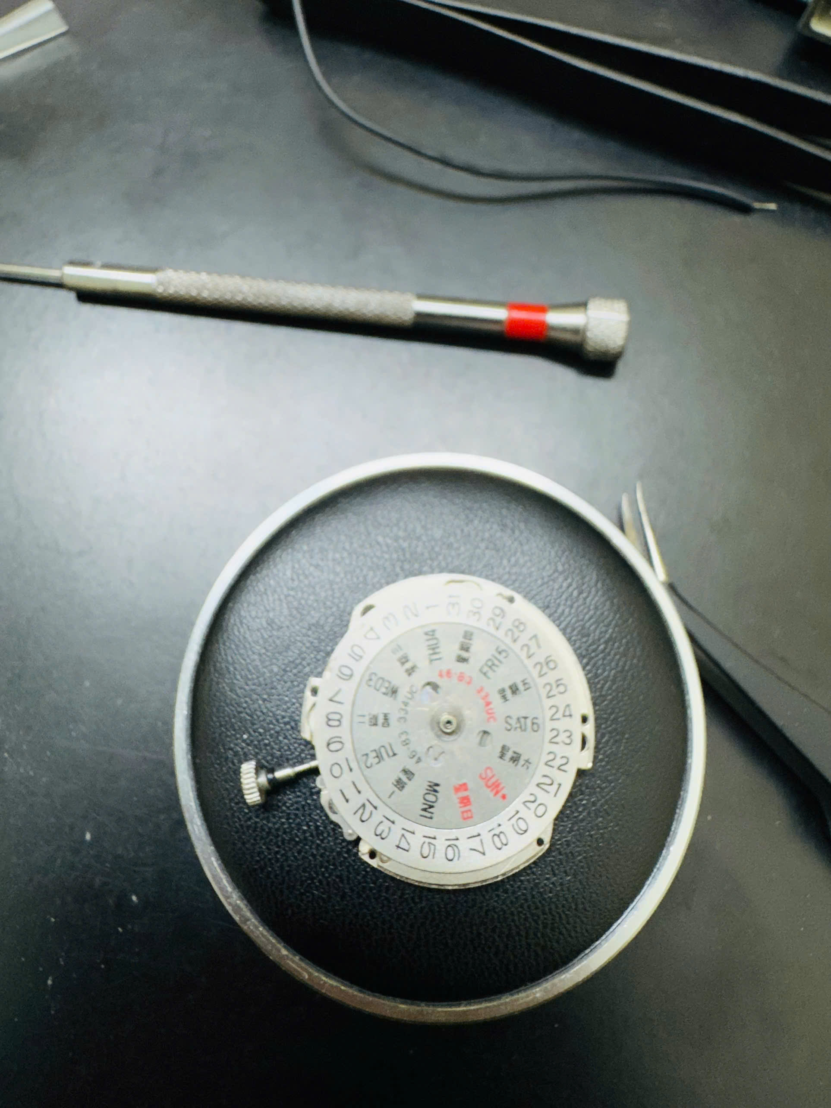

Picture: Day of the week module, complete

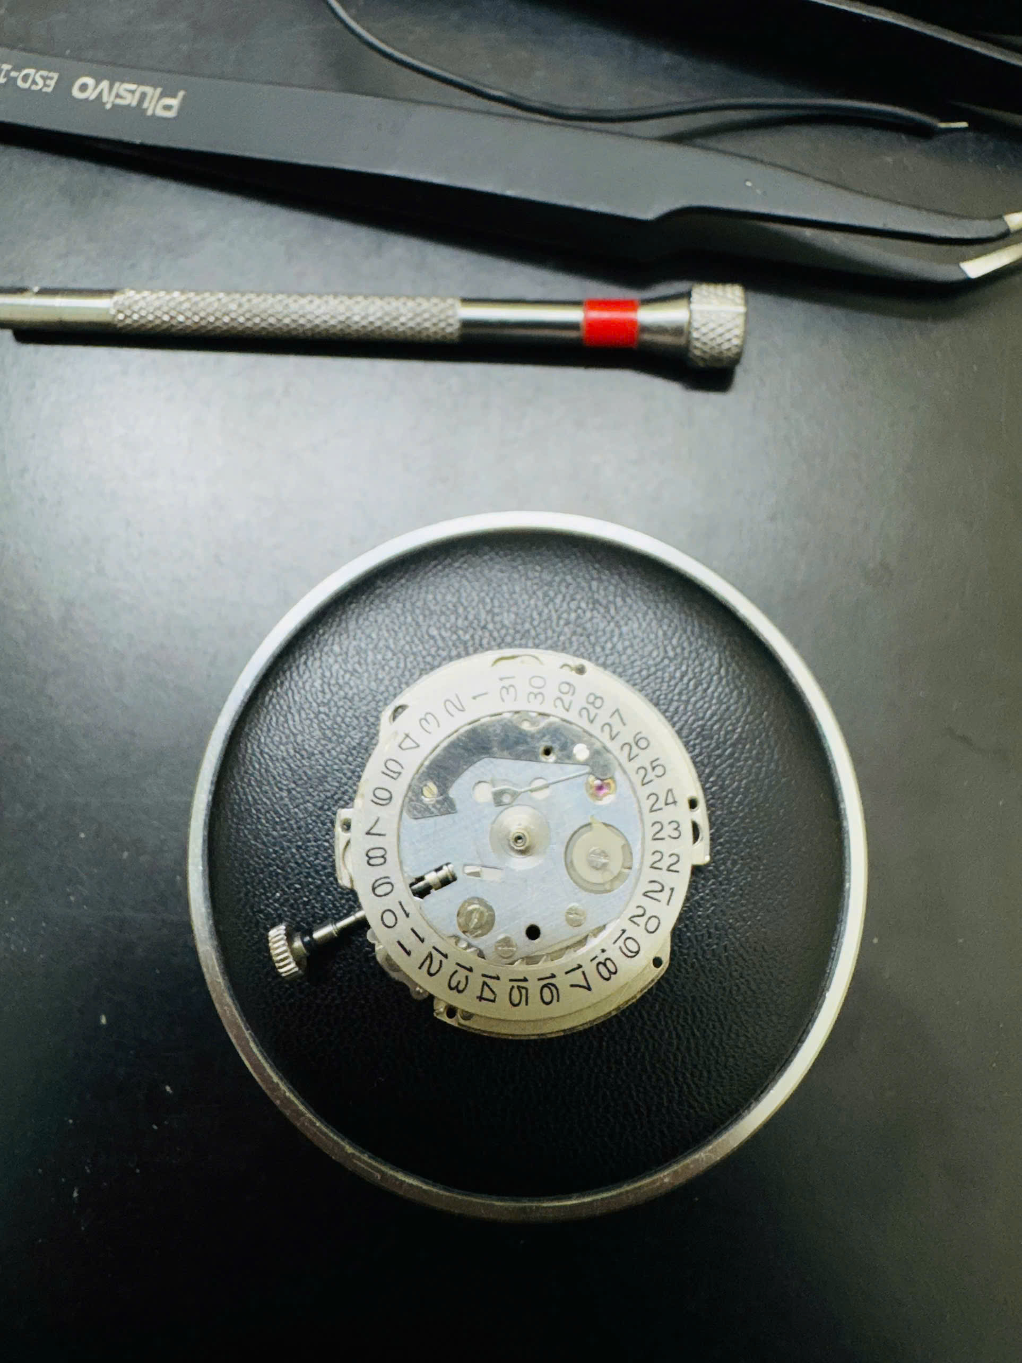

Picture: Day of the week module, without day disc.